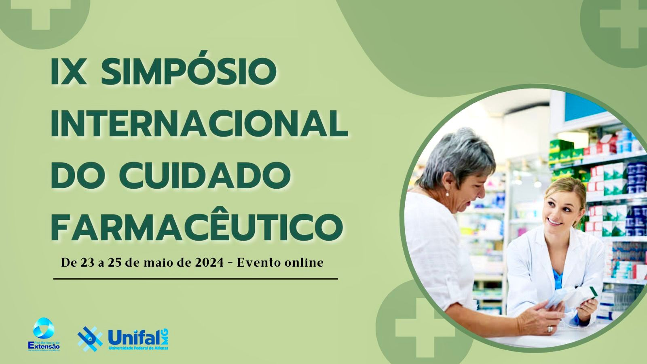
ASSESSMENT OF RESILIENCE IN PATIENTS WITH DEPRESSION UNDER PHARMACOTHERAPY FOLLOW-UP

Nayna Cândida Gomes¹, Pedro Henrique Oliveira Abrão¹, Maria Rosana Fernandes², Luciene Alves Moreira Marques¹.
E-mail: [corresponding author e-mail] | ORCID: [corresponding author ORCID]
1. Universidade Federal de Alfenas (UNIFAL-MG), 2. Universidade de Alfenas (UNIFENAS)

Resilience is a favorable individual personality trait and is directly related to a dynamic process of adaptation of human beings. Studies show that resilience, the capacity of self-regulation and self-esteem to face even difficult and adverse facts can be correlated with depression and quality of life scores. It is expected that individuals with high scores of resilience have low scores of depression and a better quality of life. The present study was proposed to shed light on the correlation of depression and resilience scores, in view of the lack of substantial research about the topic. Besides, depression is a disorder with high prevalence rates and is a leading cause of disability, resulting in increased work absenteeism in the world. This study aimed to assess resilience in depressive patients under pharmacotherapy follow-up. So far, 10 female patients over 18 years of age, living in urban areas and who had a first episode of depression or recurrent episodes were selected. Patients with evident cognitive impairment that might jeopardize the completion of the questionnaires were excluded. The Resilience Scale composed of 25 items, ranging from 1 = “I completely disagree” to 7 = “I completely agree” was applied, with scores ranging from 25 to 175. The sample consisted of 100% female patients with a mean age of 48.4 years ± 9.35. One hundred percent of the sample had chronic depression symptoms (11.7 years ± 11.65). To describe the relationship between resilience and number of years in treatment for depression, resilience and PHQ-9 and resilience and Beck inventory, linear regression models that showed low coefficients of correlation R2= 12.48%, R2= 11.65% and R2=10.94% respectively, (p>0.05) were adjusted. The small sample size was a limitation of the present study, and this may explain the lack of relationship between resilience and the factors surveyed. These results are partial, and further studies with a larger population will be conducted.

Keywords: [three to five keywords separated by semicolons. Example: Pharmaceutical Care; Mental health; Resilience; Depression; Pharmacotherapy follow-up.]

Ethics Committee approval protocol:
Suportted by:

